**G - Longest path**

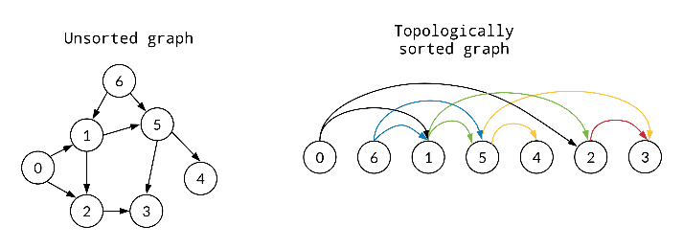Given a DAG with $n$ vertices and $m$ directed edges, find the length of the longest path.

Solution 1: Topological sorting

Topological sort, then you can use basic dp because each edge points from some node you already optimized to a future node. (there is no ‘back edges’)

Solution 2: clever dfs

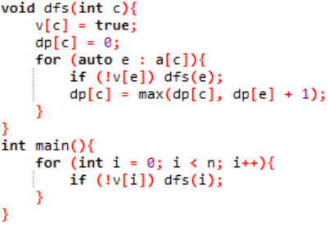dp[i] is length of longest path starting from node i

Observation: if dfs(i) is called, dp[i] will be optimized (because dfs goes through all possible descendants of i)

2 possibilities: a child of i, let’s say j is visited, which means dp[j] is already optimized; j is not visited, then we need to dfs(j). In both cases update dp[i] because j can be the next step in longest path starting from i regardless of visited or not.

**J - Sushi**

There are $n$ dishes, and each dish has 1, 2 or 3 sushi on it. In an operation, you pick a dish out of the $n$ dishes, and eat 1 sushi from it if there are more than 0 sushi on it. (If the dish has 0 sushi do nothing) What is the expected number of operations to eat all the sushi?

Intuition: $n≤300$, each dish 3 possibilities (actually 4) hmm maybe can dp[n][n][n]

dp[i][j][k] = expected number of operations to eat i dishes with 1 sushi, j dishes with 2 sushi and k dishes with 3 sushi

Base case: dp[0][0][0] = 0 (expected number of operations is 0)



$P_{1}$: probability of choosing a dish with 1 sushi, $\frac{i}{i+j+k}$

$P_{2}$: probability of choosing a dish with 2 sushi, $\frac{j}{i+j+k}$

$P_{3}$: probability of choosing a dish with 3 sushi, $\frac{k}{i+j+k}$

$P_{0}$: probability of choosing a dish with 0 sushi, $\frac{n-i-j-k}{i+j+k}$

( $\left[i+1\right]\left[j-1\right]$ because eating a sushi from a dish with 2 sushi produces a dish with 1 sushi)

$$dp\left[i\right]\left[j\right]\left[k\right]=P_{0}\left(dp\left[i\right]\left[j\right]\left[k\right]+1\right)+P_{1}\left(dp\left[i-1\right]\left[j\right]\left[k\right]+1\right)+P_{2}\left(dp\left[i+1\right]\left[j-1\right]\left[k\right]+1\right)+P_{3}\left(dp\left[i\right]\left[j+1\right]\left[k-1\right]+1\right)$$

$$dp\left[i\right]\left[j\right]\left[k\right]=P_{0}\left(dp\left[i\right]\left[j\right]\left[k\right]\right)+P_{0}+P_{1}\left(dp\left[i-1\right]\left[j\right]\left[k\right]\right)+P_{1}+P_{2}\left(dp\left[i+1\right]\left[j-1\right]\left[k\right]\right)+P_{2}+P_{3}\left(dp\left[i\right]\left[j+1\right]\left[k-1\right]\right)+P_{3}$$

$$dp\left[i\right]\left[j\right]\left[k\right]=P_{0}\left(dp\left[i\right]\left[j\right]\left[k\right]\right)+P_{1}\left(dp\left[i-1\right]\left[j\right]\left[k\right]\right)+P_{2}\left(dp\left[i+1\right]\left[j-1\right]\left[k\right]\right)+P_{3}\left(dp\left[i\right]\left[j+1\right]\left[k-1\right]\right)+1$$

$$dp\left[i\right]\left[j\right]\left[k\right]-P_{0}\left(dp\left[i\right]\left[j\right]\left[k\right]\right)=P_{1}\left(dp\left[i-1\right]\left[j\right]\left[k\right]\right)+P_{2}\left(dp\left[i+1\right]\left[j-1\right]\left[k\right]\right)+P_{3}\left(dp\left[i\right]\left[j+1\right]\left[k-1\right]\right)+1$$

$$\left(1-P_{0}\right)\left(dp\left[i\right]\left[j\right]\left[k\right]\right)=P_{1}\left(dp\left[i-1\right]\left[j\right]\left[k\right]\right)+P_{2}\left(dp\left[i+1\right]\left[j-1\right]\left[k\right]\right)+P_{3}\left(dp\left[i\right]\left[j+1\right]\left[k-1\right]\right)+1$$

$$\frac{i+j+k}{n}\left(dp\left[i\right]\left[j\right]\left[k\right]\right)=\frac{i}{n}\left(dp\left[i-1\right]\left[j\right]\left[k\right]\right)+\frac{j}{n}\left(dp\left[i+1\right]\left[j-1\right]\left[k\right]\right)+\frac{k}{n}\left(dp\left[i\right]\left[j+1\right]\left[k-1\right]\right)+1$$

$$dp\left[i\right]\left[j\right]\left[k\right]=\frac{n}{i+j+k}\left(\frac{i}{n}\right)\left(dp\left[i-1\right]\left[j\right]\left[k\right]\right)+\frac{n}{i+j+k}\left(\frac{j}{n}\right)\left(dp\left[i+1\right]\left[j-1\right]\left[k\right]\right)+\frac{n}{i+j+k}\left(\frac{k}{n}\right)\left(dp\left[i\right]\left[j+1\right]\left[k-1\right]\right)+\frac{n}{i+j+k}$$

$$dp\left[i\right]\left[j\right]\left[k\right]=\frac{i}{i+j+k}\left(dp\left[i-1\right]\left[j\right]\left[k\right]\right)+\frac{j}{i+j+k}\left(dp\left[i+1\right]\left[j-1\right]\left[k\right]\right)+\frac{k}{i+j+k}\left(dp\left[i\right]\left[j+1\right]\left[k-1\right]\right)+\frac{n}{i+j+k}$$

yey we have our dp transition!